I-R-2 Customer Owned Stock

The customer owned stock is determined via the existence of a customer number in the bin record for the inventory. In this example, if you look at the bin inventory for item 20-0433-0001, you will see that this item has only one bin tag record that is customer owned.
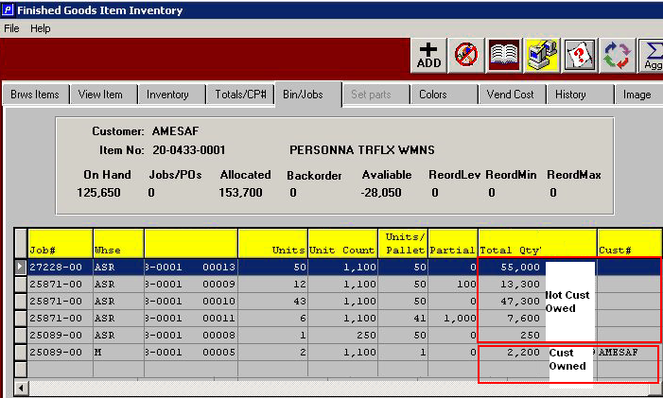

Therefore, if I run IR2 for this item you will see:
- 123,450 on hand with no check boxes (by default, the report excludes customer owned stock)
- 125,650 on hand with the “Include customer owned Warehouse” flag checked
- 2,200 on hand with the “Include customer owned warehouse” AND the “Only customer owned warehouse” both checked.
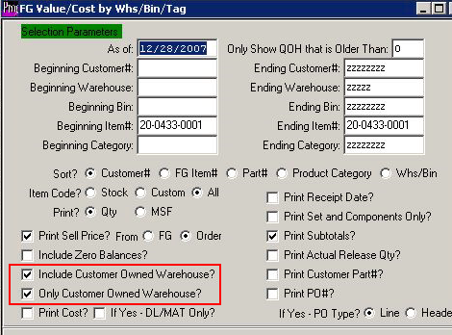

The second check box, (“Only Customer Owned Warehouse”) is a refinement of the previous check box (“Include Customer Owned Warehouse”). Therefore, the “Only Customer Owned Warehouse” should never be check on its own.

